Lord Byng Community
The Week Ahead: December 6th – December 10th

Monday: Hannukah ends

Tuesday: Hold & Secure Drill (pm)

Wednesday:

Thursday:

Friday:

Important Information:

- A safety procedure – a “hold and secure” drill.
Byng Elementary school, along with the rest of the Richmond School District, is committed to promoting Safe Schools for all students and staff. Part of that commitment is ensuring staff and students are trained and prepared to respond to any threat, minor or serious, to our school population.

Just as we practice safe procedures in case of earthquake or fire, we will now prepare for other situations that might happen in our neighbourhood (such as a broken gas line) or within our school (such as an intruder). These situations would lead us to “lockdown” the school. For the broken gas line example, we would follow Hold & Secure (Yellow) procedures – a perimeter lockdown. For an intruder, we would follow Code Red procedures - a full lockdown. These procedures have been developed with the support of law enforcement agencies and are consistent through all metro school districts.

We will have our first “hold and secure” drill on December 7th to simulate effective responses to potential safety threats. You know your child best and if you feel your child would benefit from some reassurance, please have a brief conversation with him or her before the drill.

PAC NEWS!
Please be sure to read attachments for more details
- Family Mexican dinner night opportunity
- Family Skate Night on December 14th at 5:00 – 6:30pm

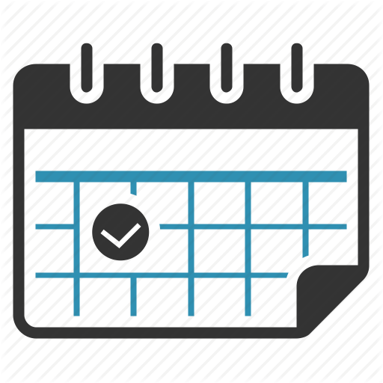
Upcoming Dates:
• December 17 – Last day of school before Winter Break
• December 18 – January 3: WINTER BREAK
• January 4 – Return to school

