Lord Byng Community
The Week Ahead: December 13th – December 17th

Monday:

Tuesday: Family Skate Night at Minoru Arenas, 5:00 – 6:30pm (PAC sponsored)

Wednesday:

Thursday: SPIRIT DAY: Wear your holiday festive wear

Friday: SPIRIT DAY: Wear your PJs to school

Important Information:

This will be the last Parent Memo that I email.
The next email will come from Ms. Schulz in the New Year 2022.

- As mentioned in a previous email, Ms. Lesa Schulz’s will be the new Principal as of January 4, 2022. I have loved all of my time here at Byng and will very much miss this community! I have many fond memories here and will always cherish my time getting to know your children. Byng is truly a great place to learn!

- We wish you all a wonderful holiday with family and friends.

PAC NEWS!
Please be sure to read attachment for more details
- Family Mexican dinner night opportunity (available for the remainder of the month)

Upcoming Dates:
• December 18 – January 3: WINTER BREAK
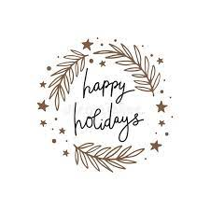
• January 4 – Return to school

